4900 Kings Row, El Monte, CA 91731
626-453-0338

Application of Initial Enrollment
2025-2026 Academic School Year

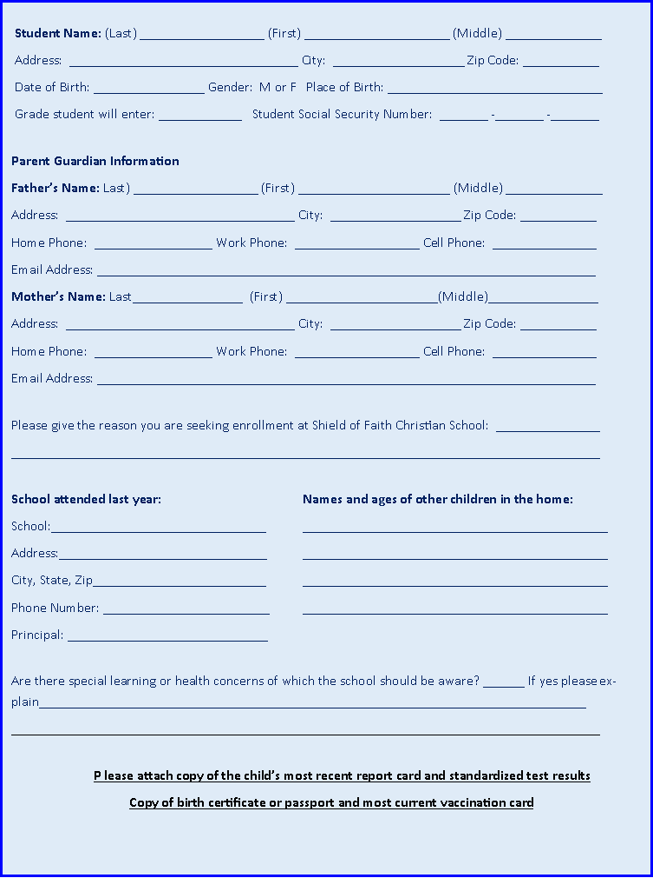
PLEASE PRINT ALL INFORMATION CLEARLY

Please read the following information and statement carefully and sign where indicated:

An appointment with the school principal will be scheduled prior to acceptance. Assessment testing may be required. There are additional enrollment forms to be filled out and a registration deposit must be made to complete the enrollment process. We may also require the completion of school recommendation forms if the applicant has attended a prior school.

I (we) hereby verify that the above information is accurate and complete. Incorrect and misleading information may result in non-acceptance or dismissal.

I (we) understand and accept our financial obligation as set forth in the current fee schedule.

Signature of Parent(s) or Guardian(s)

X______________________________________ Date_______________________

X______________________________________ Date________________________

For Office Use Only:

Interview Date: _________________ Present: _____________________________________________________

Accepted: Yes No Registration Fees Paid: __________________ Date: _______________ Check No: ______

Grade entering: __________ Teacher: _______________________ Tuition Assistance Application: Yes No

Recommendation Forms returned from:

______________________________ _____________________________ ____________________________

Transcript/School Records Request Date: _____________________ Received: ____________________________

